What Comes Out in the Wash
1 Corinthians 6:9-11, 19-20
Rick Durst, Interim Pastor PVBC
Aug. 5, 2018

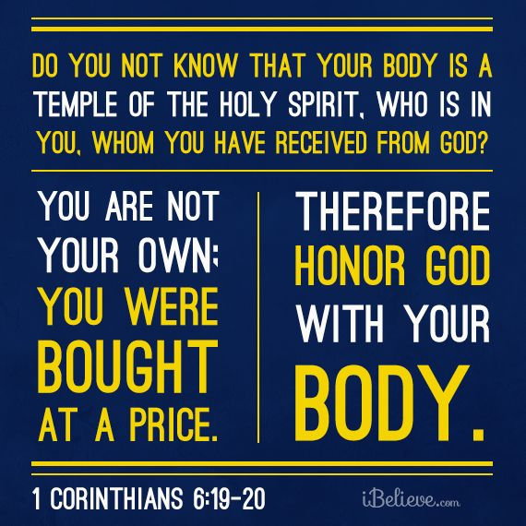

- God cleanses and commissions in the name
of the Son and by presence of the Spirit.
- God makes us the Spirit’s new address - we are walking temples (19-20).
- Christian discipleship is embracing this new self-identity.
- Sin has metastasized throughout humanity.
- Where sin abounds grace abounds more (Romans 5:20).

- Washed and waiting - behavior stopped but sometimes desire remains.
- Baptism is the outward ordination for missional service in the Name of Christ and by the presence of the Spirit.
- The purpose of baptismal ordination is to make disciples wherever we go, who walk with Jesus too.
- Think in a larger doctrinal paradigm: the priesthood of the believers (1 Peter 2:9-10).
- The job of a priest is to go into God’s presence and get a word from God and take that word to heart and out to the people.
- Punctuation can limit thinking.
With commas:
“For the perfecting of the saints, for the work of the ministry, for the edifying of the body of Christ…” Ephesians 4:12 KJV
Without commas:
“For the perfecting of the saints for the work of the ministry for the edifying of the body of Christ…”
- When this true, you do not merely come to church to hear a word, you also come with a word to share.
1 Cor. 14:26 “When you come together, everyone has a hymn, or a word of instruction, a revelation, a tongue or an interpretation.”

